South Carolina African American History Calendar Lesson
Willlie Harriford & Harry Walker - The Power of a Mentor
Lesson Overview
The impact of Mr. Harriford and Mr. Walker are significant in many regards. Both leaders have a lasting impact on future generations by participating in mentor activities that benefit the community. Mr. Harriford served as a mentor to Mr. Walker, and later both men served together as mentors to young soccer participants. It has been said that a child must see it, to begin to think about being it, and these two mentors provide young people with a positive image of a successful person giving back to the community. Mr. Harriford and Mr. Walker provide a local image of giving back to the community and helping others. Students should also explore the positive relationships that exist from mentor activities, as well as the traits that a mentor should possess. Students will learn about the accomplishments of Willie Harriford and Harry Walker and the students will make connections about mentors and the power of a mentor. Students will also identify traits and aspects of mentors and mentees and characteristics of positive relationships. Students will also examine the societal contributions of the two accomplished men and discuss the impact from their contributions to the community. Students will conclude by composing a summary of their thoughts about traits of mentors.

Overarching Inquiry Question
What is the impact of a mentor relationship?

All units support the Profile of the South Carolina Graduate with students using skills to uncover content exposed when exploring the Overarching Inquiry Question.
Theme
Multiple themes are addressed in this lesson, Civics and Government, Human Systems, and Civic Engagement. Students will have the opportunity to discuss the Civics and Government theme as they examine the role and responsibility of the citizen and the consequences within their communities. Students will examine Human Systems as they study human activities and characteristics and political systems as they discuss university political systems. Students will also examine Civic Engagement as they discuss the active participation of a citizen reflects personal values and a society’s prioritization of civil rights and responsibilities.

Skills Emphasis at a Glance
Students will spend most of the time working in the skill of CO: Comparison. Students will explore the comparison of the featured leaders and their mentor relationship.
Standard(s)
Grade 1
Standard 4: Utilize the college and career skills of a political scientist to understand and display civic dispositions about contemporary South Carolina.
1.CG.3 Demonstrate ways to display active and responsible citizenship in local and state government.
Grade 2
Standard 4: Responsible citizenship requires individuals of diverse cultural backgrounds to employ dispositions that promote strong relationships to develop solutions to communal problems.
2.CG.2 Use primary and secondary sources to research a national figure who demonstrated civic dispositions
Grade 8
Standard 5: Demonstrate an understanding of the impact of world events on South Carolina and the United States from 1929 to present.
8.5.CC Analyze the continuities and changes in South Carolina’s identity resulting from the civic participation of different individuals and groups of South Carolinians.
I Can Statement(s)
I can statements are designed to help guide student understanding through scaffolds of learning as they progress through an understanding of the Overarching Inquiry Question.
- I can identify traits of a successful mentor.
- I can identify traits of an impactful mentor.
- I can identify the impact of a mentor.
Lesson Sequence of Teacher Instructional Practices and Actions Students will Take to answer the Overarching Inquiry Question | Instructional Guidance and Resources  Instructional Guidance and resources listed below offer suggestions for educators to assist students in reaching the goals of the proposed sequence.
I can statement 1: I can identify traits of a successful mentor.

The teacher introduces the lesson and gives a definition of mentor.  Mentor- a wise and trusted counselor, supporter or teacher. | Mentor definition from Dictionary.com
Teacher instructs students to create word web of what traits a mentor possess. Students may brainstorm with shoulder partner or as a whole class with the teacher. | Word Web sample- this may be teacher created or use this sample  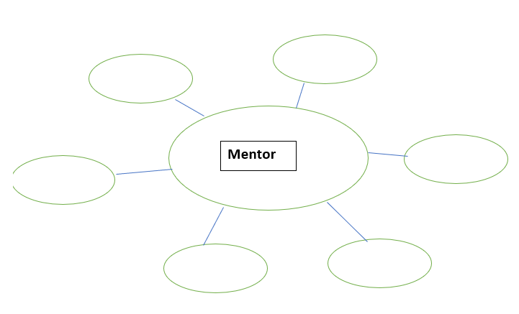  The teacher could ask probing questions for students to consider, examples: What traits would you like to have in a mentor? If a mentor helped you what would you like them to help you with? What characteristics would you like for them to have? What activities would you like a mentor to help you with?  The students
Formative Performance: The students will create the word web and will have traits that they can identify as being positive traits of a mentor. The student can refer to this chart in future activities. | Teachers should look for positive traits in a mentor. Teachers may want to ensure that negative traits are not present in the word web. Teachers may want to
I can identify traits of an impactful mentor.

For students that are younger, the teacher should read aloud the biographies of Harriford and Walker from the calendar. If the students are older, they could receive a copy of the biography of Harriford and Walker to read. | The teacher may have to explain some of the roles the men were engaged in, so the students understand.  Teachers may have to read the biography aloud based on the reading level of the students.
The teacher will revisit the definition of a mentor and then have students discuss how Harriford and Walker serve as mentors and mentees. Then teachers should have students brainstorm traits Harriford and Walker both share with their word web. The students could continue to fill in their word web and add traits hat they see similarities. | The teacher may need to demonstrate the comparison of traits and should model the first comparison.  The teacher may need to encourage discussion about Mr. Harriford serving as a mentor to Mr. Walker and then the two men mentoring a soccer team.
Formative Performance: Students are going to read the biography summaries, then connect the information to their graphic organizer. Then students should add or fill more information into their graphic organizer. Students should make connections to the impact of the men on the community. | Look for students making connections between Mr. Harriford and Mr. Walker and the connection to community. Teachers should also look for students making positive connections between the positive impact of a mentor and the lasting relationship between a mentor and mentee.
I can identify the impact of a mentor.
Students should brainstorm leaders that have a positive role in their community. They should also brainstorm do they have a mentor, and what traits do their mentor share with Mr. Harriford and Mr. Walker. Students should also think about how they can be a mentor. | Teachers may need to encourage the students in the brainstorming activity. Teachers may need to encourage students to think about teachers, coaches, a family member, community member as a mentor. Teachers may need to encourage students to think about who may see them as a mentor, like a younger sibling or team mate.
After brainstorming, students will apply this to a writing sample. Students will follow a prompt as provided by the teacher and submit their writing. | The teacher should choose an appropriate writing level relating to grade level and academic development of the student. First and second grade students may need more support in writing and formatting their ideas and teachers may suggest a drawing/ visual that represents a positive mentor role.  Suggested Writing prompts-  1st grade- Draw a picture and write about a time you enjoyed with a mentor.  2nd grade-  8th grade. Write about a time that a mentor had a positive effect on your life, please include traits from the mentor that connected with you.  Another topic could be for students to write about the traits you will use when in a mentor role.
Formative Performance Students will create a writing on the traits of a mentor. | The teacher will provide guidance and support for the students to complete the writing activity. The teacher may need to provide support and remind students to revisit the graphic organizer to help during the writing.
Summative Performance Teachers should introduce the definition of a mentor, then share the biography of Mr. Harriford and Mr. Walker and lead students in a discussion on their roles as a mentor. Teachers should check for understanding of the definition of a mentor and help students make connections to people that serve as mentors to the students through the word web and discussion. If students are struggling, teachers could share personal stories of mentors. Teachers could also encourage students who may not identify a mentor immediately by having the student think of a favorite teacher, family member, community member or coach. Teachers could assess student thinking and understanding from the discussion and writing activity. Students should demonstrate mastery of the I can statement through writing or visual creation.

References
Dictionary.com. (n.d.). Mentor definition & meaning. Dictionary.com. Retrieved December 14, 2021, from https://www.dictionary.com/browse/mentor.

The teacher will use biographical resources from the African American History Calendar on Mr. Harriford and Mr. Walker.

